Lab manual 10

Submitted to: M. Affan

Name: Hussain Aun Ali

ME-15(A)

Roll No: 463652

1. **Iterate Through Vector Using Iterators and print all pushed elements. Next you need to push integer 5 and remove element at that position.**

int num, i;

vector<int> vec;

for(i=0; i<10; i++){

cout<<"Enter a value in the vector.\n";

cin>>num;

vec.push_back(num);

}

cout<<endl<<"Current vector: \n";

for(i=0; i<10; i++)

{

cout<<vec.at(i)<<", ";

}

vec.erase(vec.begin()+5);

vec.insert(vec.begin()+5, 5);

cout<<endl<<"New Vector: ";

for(i=0; i<10; i++)

{

cout<<vec.at(i)<<", ";

} 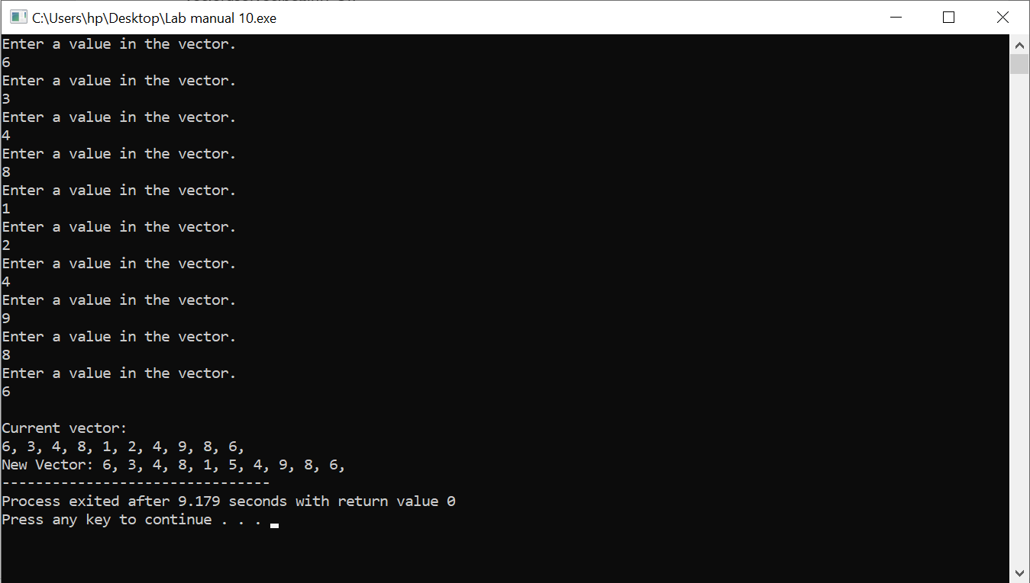

1. **Write a complete C++ program that uses 2 vectors, 1 for names (string) and 1 for grades (int)** 
   1. **Ask the user for the number of name/grade pairs that will be entered.**
   2. **Display the mean of the grades.**
   3. **Display the median of the grades.**
   4. **Display the mode of the grades.**
   5. **Display the names of the students with the mode as their grade.**

int mean(vector<int> vec){

int sum=0, size=vec.size();

for(int i=0; i<vec.size(); i++){

sum=vec[i]+sum;

}

int mean=sum/vec.size();

return mean;

}

int median(vector<int> vec){

int i, j, temp, median;

for(i=0; i<vec.size()-1; i++){

for(j=0; j<vec.size()-1; j++){

if(vec[j]>vec[j+1]){

temp=vec[j];

vec[j]=vec[j+1];

vec[j+1]=temp;

}

}

}

int n=vec.size();

if(n%2 == 0){

median=((n/2)+((n/2)+1))/2;

}

else{

median=(n+1)/2;

}

return vec[median-1] ;

}

int mode(vector<int> vec){

int repetition=0, maxrep=0, mostrepeated;

for(int i=0; i<vec.size(); i++){

repetition=0;

for(int j=0; j<vec.size(); j++){

if(vec[i]==vec[j]){

repetition++;

}

}

if(repetition>maxrep){

maxrep=repetition;

mostrepeated=vec[i];

}

}

return mostrepeated;

}

void students_mode(vector<string> vec, vector<int> vec2, int mode){

int i=0;

cout<<"Students with Grade Equal to Mode: ";

for(i=0; i<vec.size(); i++){

if(vec2[i]==mode){

cout<<vec[i]<<" , ";

}

}

}

int main(){

vector<string> names;

vector<int> grades;

int i,j,input,num,Mean,Median,Mode;

string name;

cout<<"Enter Number of Students. ";

cin>>num;

for(i=0; i<num; i++){

cout<<"Enter the Name of Student: ";

cin>>name;

names.push_back(name);

cout<<endl<<"Enter Grade of Student in Percentage: ";

cin>>input;

grades.push_back(input);

}

system("cls");

Mean=mean(grades);

cout<<endl<<"Mean is: "<<Mean<<endl;

Median=median(grades);

cout<<"Median is: "<<Median<<endl;

Mode=mode(grades);

cout<<"Mode is: "<<Mode<<endl;

students_mode(names, grades, Mode);

}

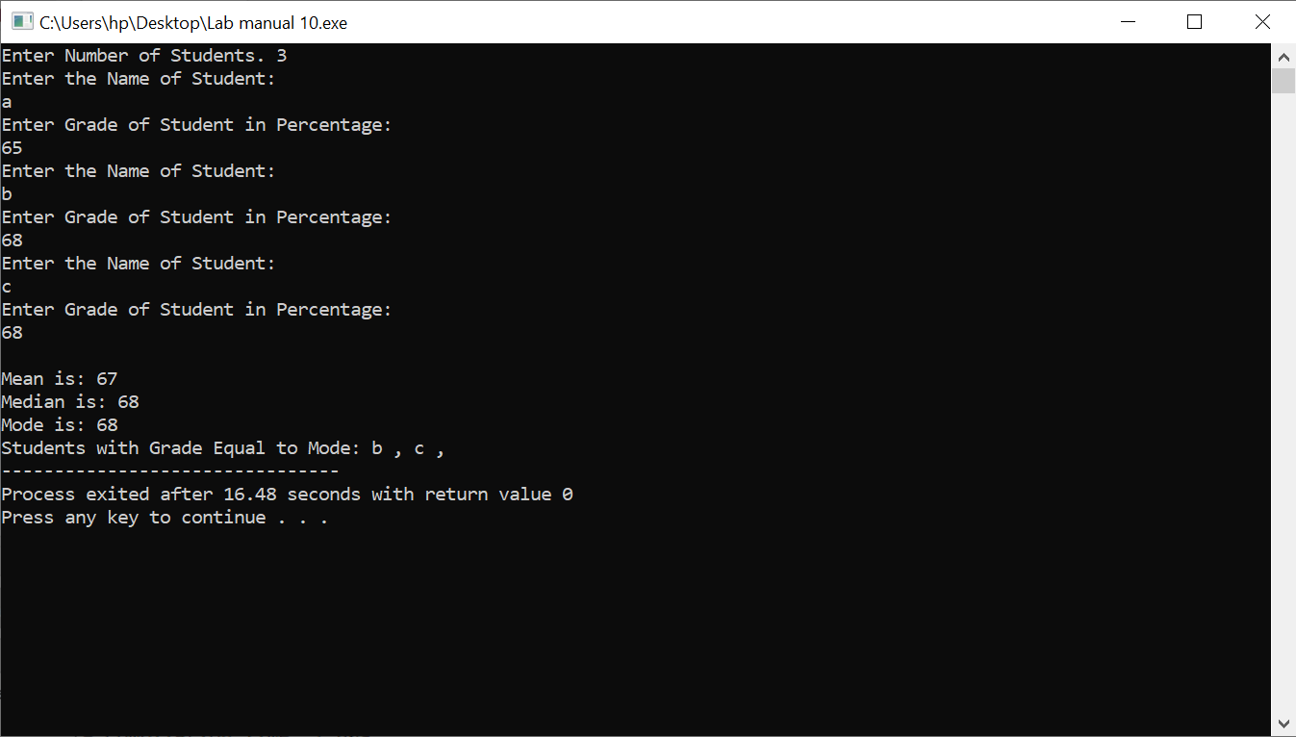

1. **Write a program to print the area and perimeter of a triangle having sides of 3 m, 4 m and 5 m by creating a class named 'Triangle' with a function to print the area and perimeter.**

class triangle{

public:

int length1=6;

int length2=8;

int length3=10;

int perimeter(){

return length1+length2+length3;

}

double area(){

int area,m;

m=perimeter()/2;

return sqrt(m * (m - length1) * (m - length2) * (m - length3));

}

};

int main(){

triangle tri;

int perimeter;

double area;

perimeter=tri.perimeter();

area=tri.area();

cout<<"Area is: "<<area<<endl;

cout<<"Perimeter is: "<<perimeter<<endl;

} 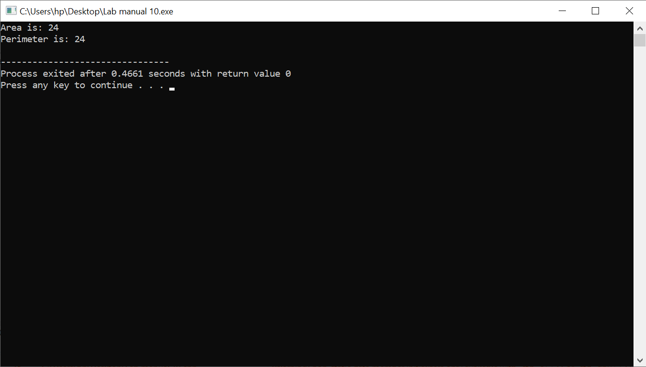

1. **Write a structure to store the names, salary, and hours of work per day of 10 employees in a company. Write a program to increase the salary depending on the number of hours of work per day as follows and then print the name of all the employees along with their final salaries.**

struct Employee {

string name;

double salary;

int hoursperday;

};

int main(){

const int no_employees = 10;

Employee employees[no_employees];

for (int i = 0; i < no_employees; ++i) {

cout << "Enter name of employee " <<": ";

cin >> employees[i].name;

cout << "Enter salary " << ": ";

cin >> employees[i].salary;

cout << "Enter hours of work per day " << ": ";

cin >> employees[i].hoursperday;

cout << endl;

}

for (int i = 0; i < no_employees; ++i) {

if (employees[i].hoursperday >= 12) {

employees[i].salary += 150;

} else if (employees[i].hoursperday >= 10) {

employees[i].salary += 100;

} else if (employees[i].hoursperday >= 8) {

employees[i].salary += 50;

}

}

cout << "Employee Details:" << endl;

for (int i = 0; i < no_employees; ++i) {

cout << "Name: " << employees[i].name << ", Final Salary: $" << employees[i].salary << endl;

}

}

